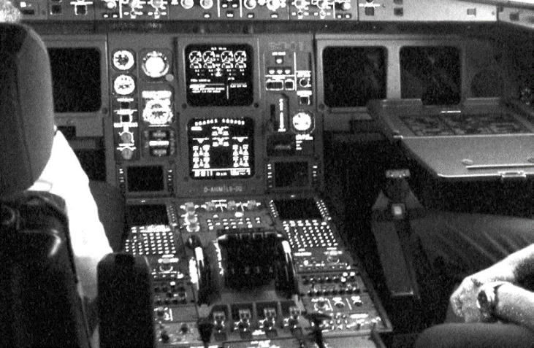

**Timing Management**

***Objective: In this lab you will create a LKM called*** extimer***. The LKM will exercise several of the kernel timing management functions.***

1. The first thing extimer should do is delay its startup by 10 seconds, keeping in mind you DO NOT want to freeze the entire system for that period of time .

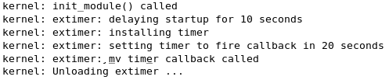

1. Next, create a callback function called “my_timer_callback” and create a kernel timer to fire it off in 20 seconds.
2. Finally make sure to remove the kernel timer before unloading the module.